Attachment 2 – Pictures
Material of Rags & & Towels are 100% cotton.
Wiper Rags for Production

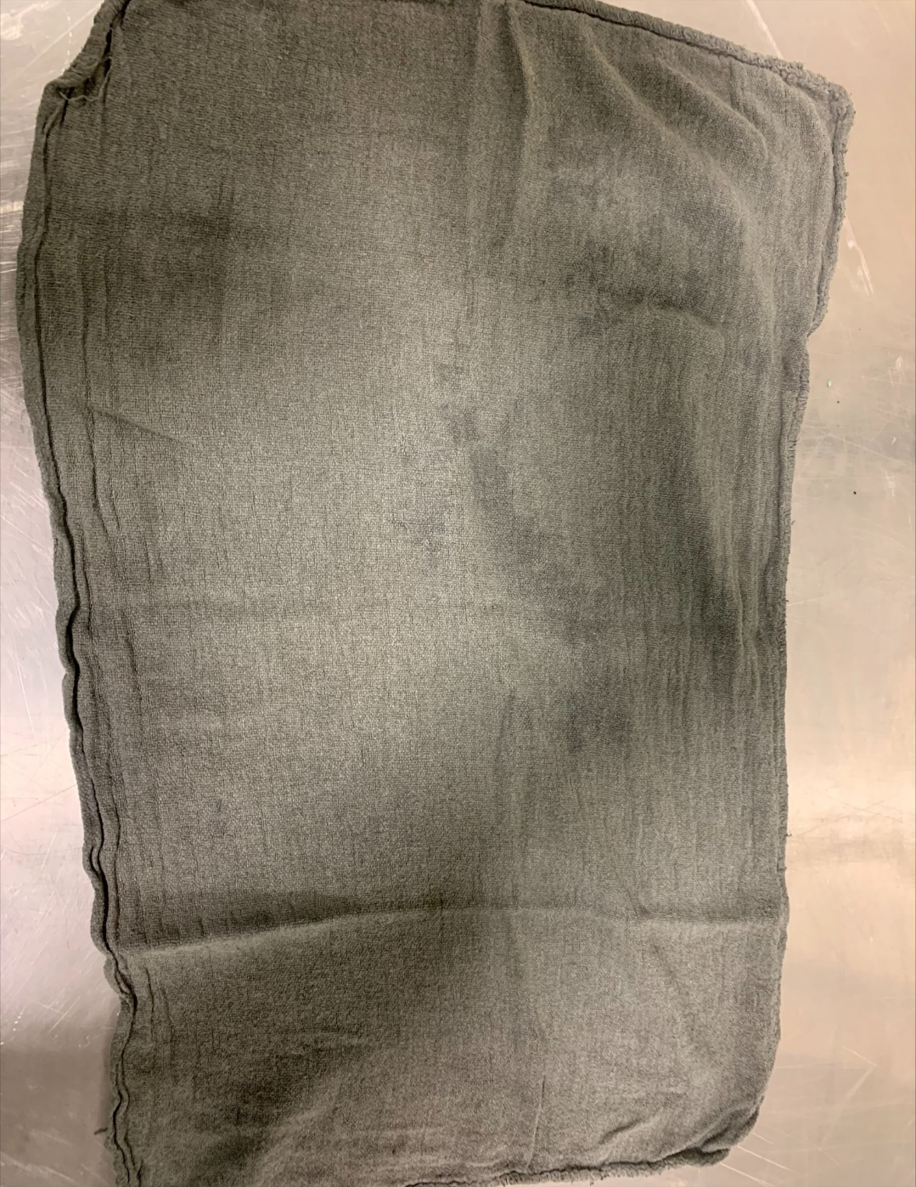
Plate Printing Rag 18”x30” (Blue/Grey) - 5.1.2- Blue/Grey Plate Printing Shop Towels/Wipes.

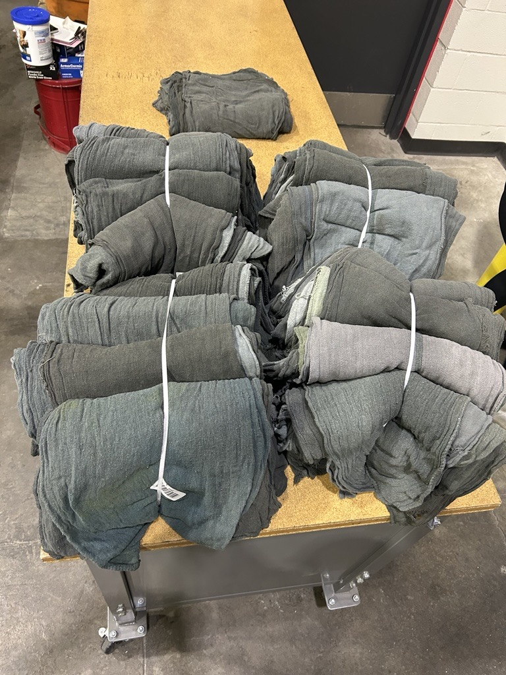
Plate Printing 18”x30” (Blue/Grey) - 5.1.2- Blue/Grey Plate Printing Shop Towels/Wipes.
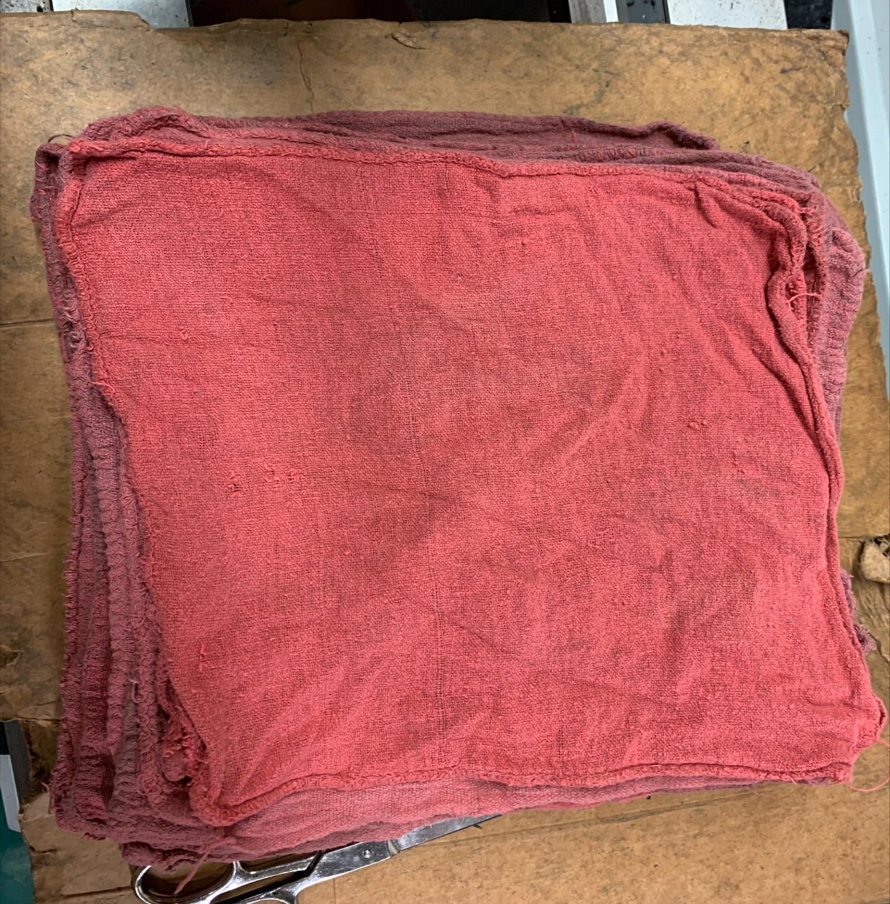
Roller Recovery 18”x18” (Red) 5.1.3- Red Shop Towels/Wipes
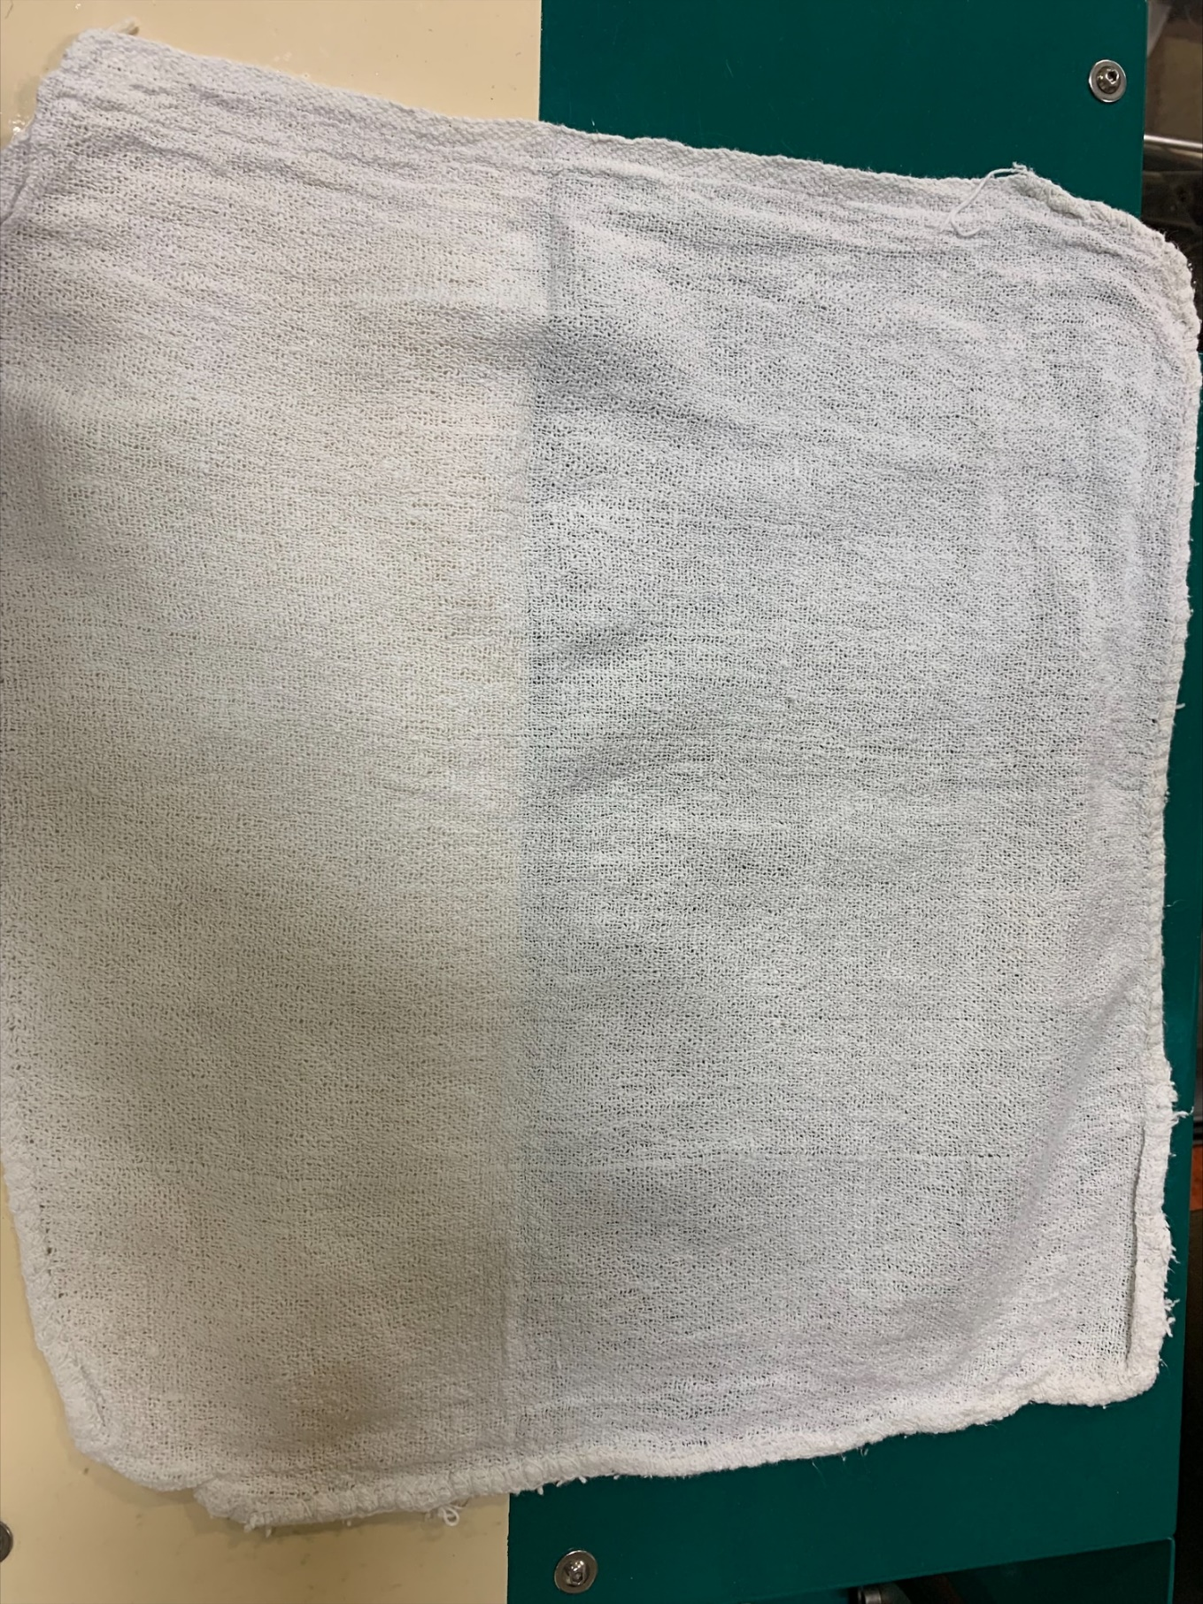
Ink Mill /Rotary Screen 18”x18” (Virgin White) - 5.1.5- White Virgin Towels
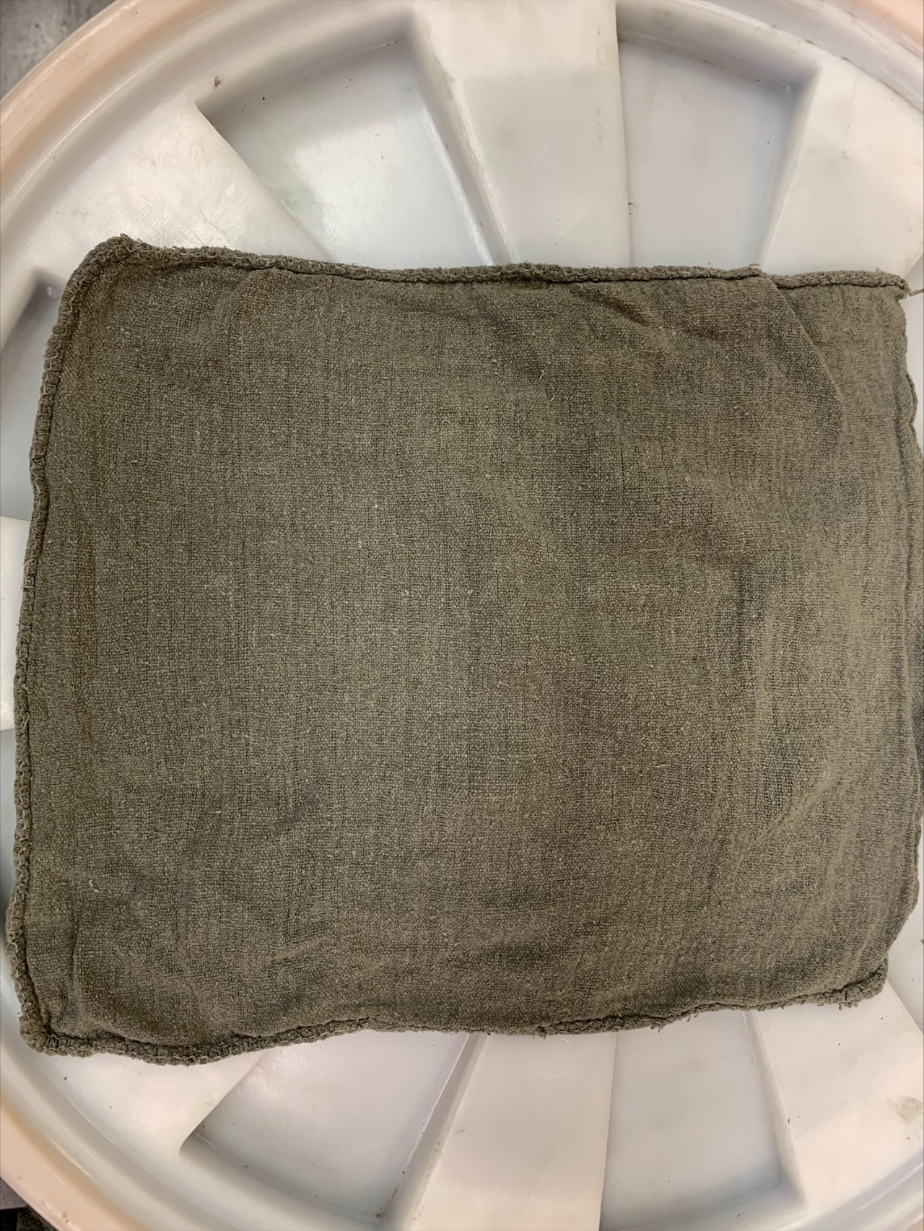
Offset 18”x18” (Once Virgin White, Now Washed) 5.1.4 – Blue/Grey Offset Printing Shop Towels/Wipes

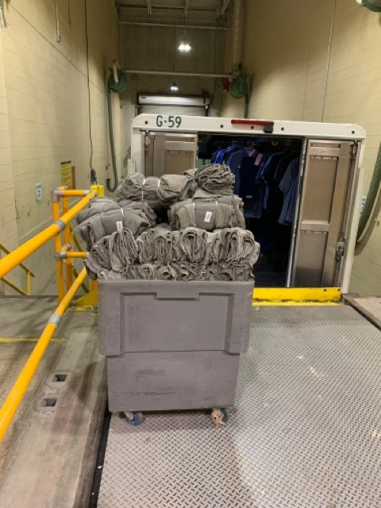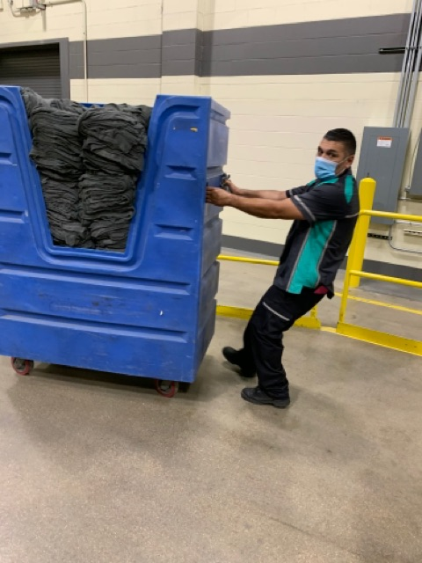
5.1.6 - Gondolas. The contractor shall provide at least 10 individual plastic gondolas, 1.5 cu yd. or equal on wheels to hold clean towels, and at least 14 individual large laundry gondolas on wheels, 1.5 cu. yd. or equal to hold dirty bath towels in the main male and female locker rooms, Electro Machinist locker room, Ink Mill male and female locker rooms, Security Police male and female locker rooms, and the Waste Treatment Plant locker room. Placement of the gondolas for clean blue and red towels will be specified by the COR.

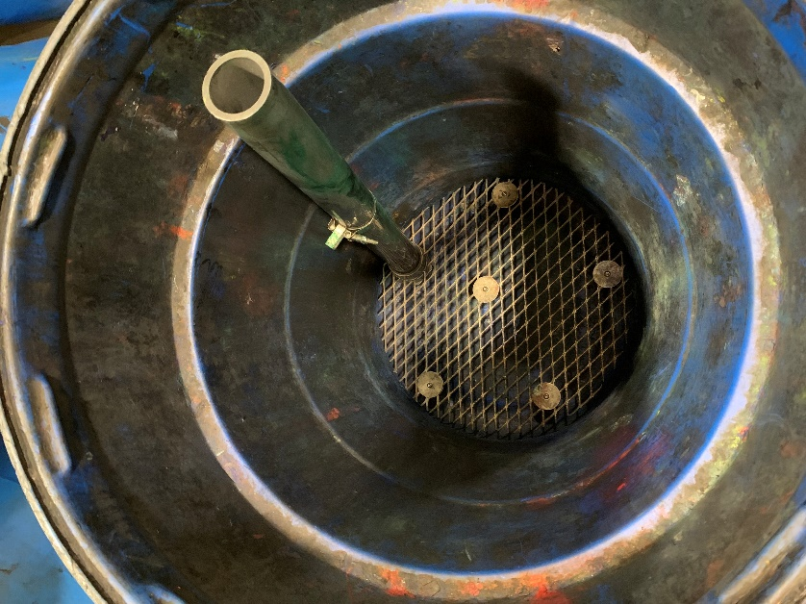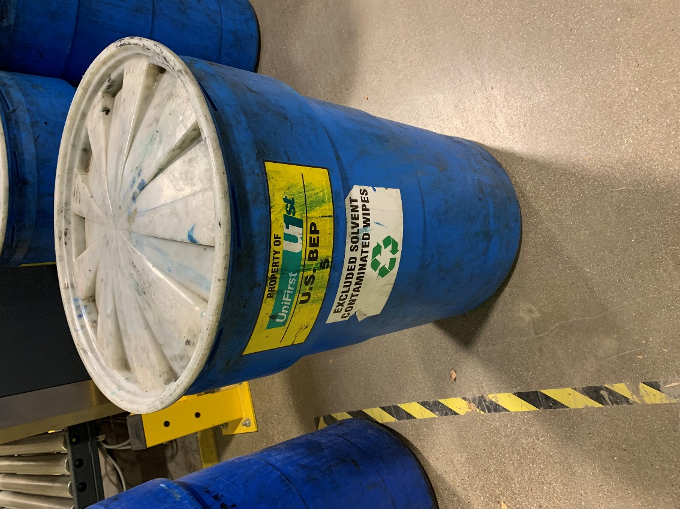
5.1.7 - Plastic Drums/Barrels. The contractor shall provide at least 50 individual, 55-gallon plastic drums with lids that twist to lock to hold soiled production rags, i.e., ink wipes, ink towels. The towels are spun in a centrifuge prior to being stored in dirty laundry to remove the majority of excess liquid. 10 individual plastic 1.5 cu yd. or equivalent gondolas on wheels to hold return laundered towels. Placement of the above items will be specified by the COR.

